Types of Association – One-to-One

📌 Definition:
# Source: AI Source: Provided by: [Data Path: Persons Table -> ID Column: 1, Name_En Column: Motasem Essam] -> From: [Chatgpt (GPT‑5 Mini)] on [12/9/2025]
One-to-One association is a relationship where one object is associated with exactly one other object.

🧠 Simple idea:
# Source: AI Source: Provided by: [Data Path: Persons Table -> ID Column: 1, Name_En Column: Motasem Essam] -> From: [Chatgpt (GPT‑5 Mini)] on [12/9/2025]
One-to-One = “1 ↔ 1” 👤➡️🆔

🔍 Key characteristics:
# Source: AI Source: Provided by: [Data Path: Persons Table -> ID Column: 1, Name_En Column: Motasem Essam] -> From: [Chatgpt (GPT‑5 Mini)] on [12/9/2025]
- 🔗 One object ↔ One object
- 🧩 Each object has only one related object
- 🔄 Both objects can exist independently
- ⚙️ Represents a direct and exclusive relationship

📌 Real-world examples:
# Source: AI Source: Provided by: [Data Path: Persons Table -> ID Column: 1, Name_En Column: Motasem Essam] -> From: [Chatgpt (GPT‑5 Mini)] on [12/9/2025]
- 👤 Person ↔ Passport
- 🧑 User ↔ Profile
- 🚗 Car ↔ Engine (in some designs)
- 🏠 Person ↔ Address (if modeled as one-to-one)

📌 Example (Java-style):
# Source: AI Source: Provided by: [Data Path: Persons Table -> ID Column: 1, Name_En Column: Motasem Essam] -> From: [Chatgpt (GPT‑5 Mini)] on [12/9/2025]
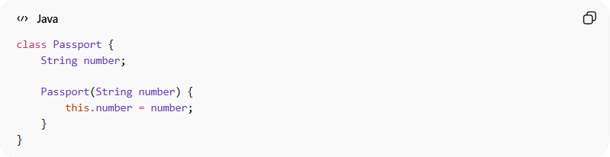
class Passport {
String number;

Passport(String number) {
this.number = number;
}
}
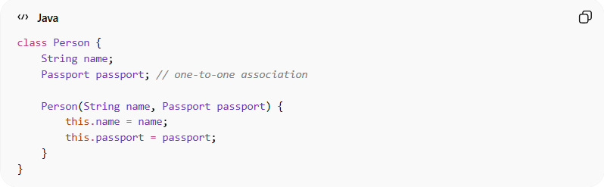
class Person {
String name;
Passport passport; // one-to-one association

Person(String name, Passport passport) {
this.name = name;
this.passport = passport;
}
}

Usage:
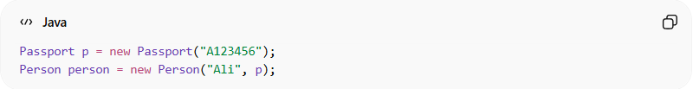
Passport p = new Passport("A123456");
Person person = new Person("Ali", p);
👉 One person has only one passport.

🔄 Relationship diagram:
# Source: AI Source: Provided by: [Data Path: Persons Table -> ID Column: 1, Name_En Column: Motasem Essam] -> From: [Chatgpt (GPT‑5 Mini)] on [12/9/2025]
Person ↔ Passport

🎯 Why it is important:
# Source: AI Source: Provided by: [Data Path: Persons Table -> ID Column: 1, Name_En Column: Motasem Essam] -> From: [Chatgpt (GPT‑5 Mini)] on [12/9/2025]
- 🧩 Models exclusive relationships
- 🔄 Keeps data organized
- ⚙️ Useful in database design (1:1 relations)
- 🧠 Simplifies system structure

🎯 Summary:
# Source: AI Source: Provided by: [Data Path: Persons Table -> ID Column: 1, Name_En Column: Motasem Essam] -> From: [Chatgpt (GPT‑5 Mini)] on [12/9/2025]
One-to-One association means each object is connected to exactly one other object, forming a direct and exclusive relationship.

